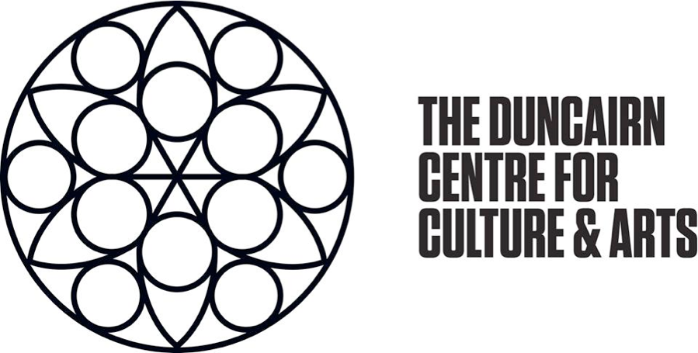
The Duncairn Reception Volunteer

What is The Duncairn?
The Duncairn is a vibrant welcoming community arts hub proudly based in north Belfast since 2014. The Duncairn is run by a tight team of staff and volunteers and has a strong focus on community. It offers art classes & workshops, a full music programme and much more, ensuring that people of various interests , backgrounds and ages are catered for.
Our Mission:
Inspire Communities, Develop Audiences, Strengthen the Sector.
Create a shared space arts facility that will contribute to North Belfast’s cultural, social, political and economic rebirth.
Showcase, support & develop the work of young emerging local artists.
Create a new arts-based model of engagement with disenfranchised, marginalised and disadvantaged communities in North Belfast.
Our Values:
Connection & Inclusion - We are community-oriented. We strive to provide a space accessible to anyone and everyone. We listen to our community and respond with them for their cultural needs.
Creativity - "We must create to know who we can be", we have adopted Stephen James Smith's poem as our motto. We believe in the power of the arts to bring about social change. We nurture talent and the creatives of the future.
Environmental sustainability - We believe we must do our part to solve the climate emergency. We want to inspire people that change is possible. We advocate for climate action.

Reception Volunteer
The role
The Duncairn runs an annual arts and crafts calendar and an ongoing programme of events throughout the year. We are looking for volunteers to join our team as Receptionists. The benefits work both ways: You gain skills & experience and give back to the community, we get more people on board to enhance and improve our work. As a Receptionist, you will be the first point of contact for The Duncairn. Our Receptionist’s duties include offering administrative support across the organization. You will welcome patrons and greet people who visit us. You will also coordinate front-desk activities, including distributing correspondence and redirecting phone calls.
Main Tasks
- Receiving visitors at the front desk by greeting, welcoming, directing and announcing them appropriately
- Answering, screening, and forwarding incoming phone calls
- Receiving and sorting daily mail
What is required from you
- We need you to have good communication skills, and to enjoy working with the public. You will be dealing with a wide range of people of all ages and backgrounds.
- Reliability – This is probably the most important thing we ask of you. If we can’t rely on you then a lot of people are left in the lurch. Others will need to take on the work you were supposed to do, as well as their own. This can have a significant impact on a small team. Please do bear this in mind.
- Minimum time commitment: between one and three days/half days a week. Shifts are distributed Monday to Friday, between 9am and 5pm.
- It is important that you can take instruction and work well within a team, while other occasions will require that you can take initiative and work on your own.
What’s in it for you?
This role is perfect for someone interested in gaining experience in front of house receptionist role, who enjoy live music and the arts, or simply aims at giving back to the community by helping The Duncairn be the best that it can.
Training - We want to create a fully rounded role for the person who is going to be joining our team. You will be shown the ropes by the volunteer or staff member who is in charge on the night. All team members will be happy to help. The Duncairn will also be providing core training to support and enhance your role here. Additional training is available for volunteers on topics like Health & Safety and Carbon Literacy.
Management - We consider our volunteers as full members of the Arts Team. As such, you will have a supervisor who will support and manage your role. They will be responsible for your induction, supervision, training, and expenses. You will undergo a three-month settling in period, and meetings will be arranged to check that the role is matching the needs of the volunteer and The Duncairn.
Expenses - We will reimburse your reasonable mileage/transport expenses.
T-shirt – a Duncairn T-shirt will be provided.
Please Note
- You need to be older than 16 years of age to join our volunteer group.
- We’re a good, happy, open, friendly team putting everything we can into making The Duncairn work. This role is in equal part about developing the volunteer, developing the team, and developing The Duncairn. We need to work together for this to work at all.
- Any information you give us will be held in the strictest confidence and will only be seen by relevant staff. We reserve the right to decline applications at our own discretion.
- The Duncairn is committed to making people feel welcome and keeping them safe from harm. We are also committed to promoting equality and discouraging discrimination. We expect all staff, volunteers and artists to comply with our policies on Child Protection, Health & Safety and Equality – these policies will be available to read in further communication.

